SOS Water Wellness Data Charts 2025
Samples Taken by: Ann Ghyzel, Nell Gardner & Dennis Chasse
Observations by: Farmer Gardner
Instrument used: Hanna Instruments model #HI98199 Multiparameter Meter pH/mV, EC, Dissolved Oxygen & Temperature, HI3874 Nitrate Test Kit and HI3833 Phosphate Test Kit.
Locations:
Sodus Bay, surface water, water depth ~ 2-4 ft:
1st Creek
2nd Creek
3rd Creek
Bay Bridge
Oak Park (Clark Creek)
Lake Bluff (East End of Crescent Beach)

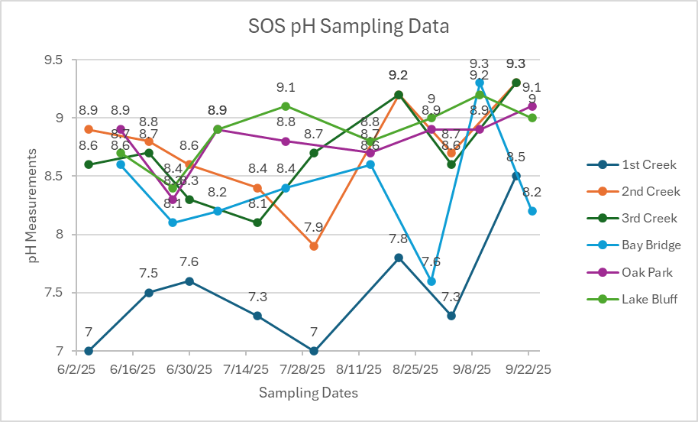

Note: Most fish prefer pH range from 6-9.
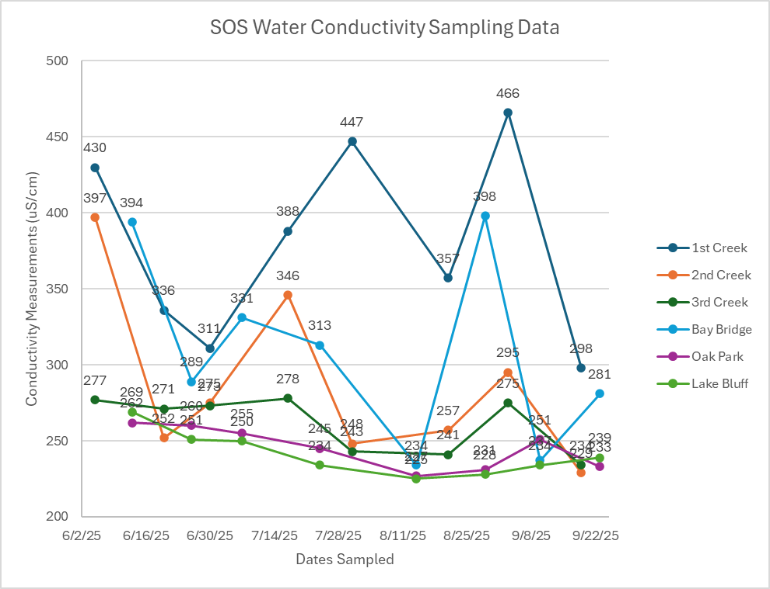
Note: High conductivity (1000s of uS/cm) indicates the water is salty or contaminated with chemicals

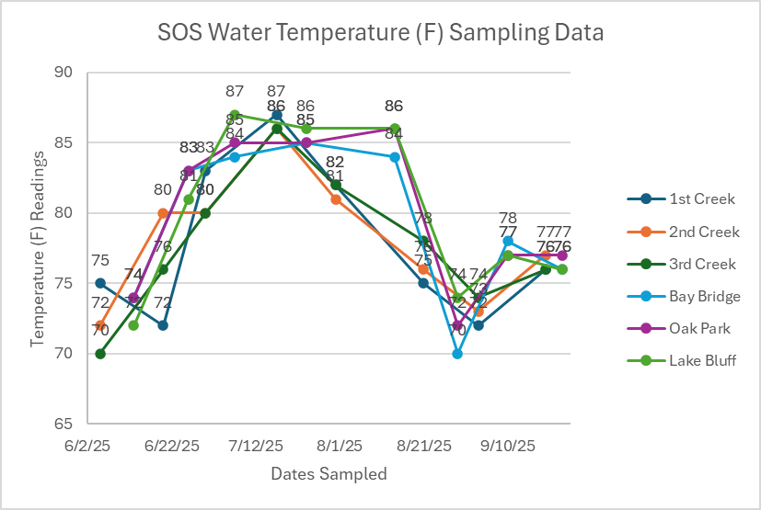
Note: Water temperature affects the growth of plants and the amount of dissolved oxygen

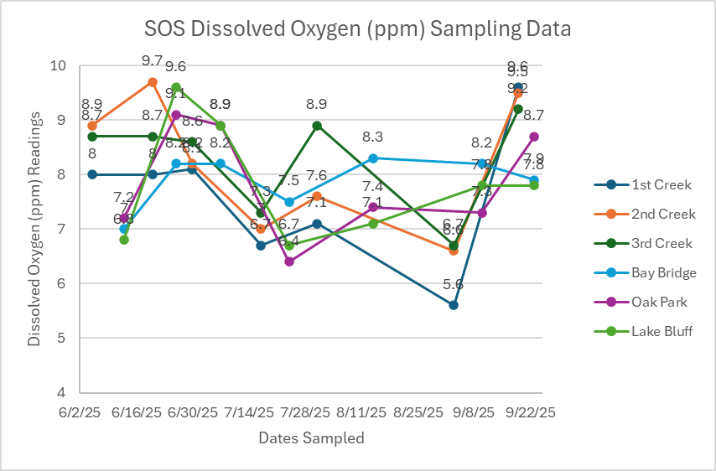

Note: Dissolved oxygen <5 ppm can negatively affect fish. Dissolved oxygen decreases as water temperature increases.

